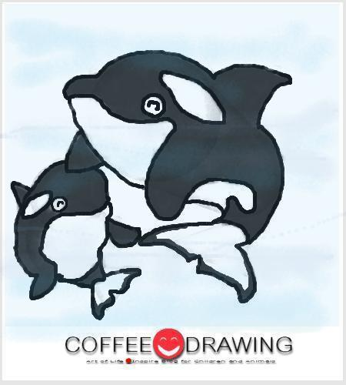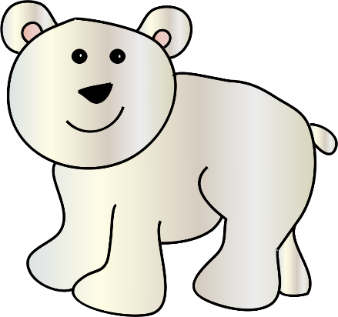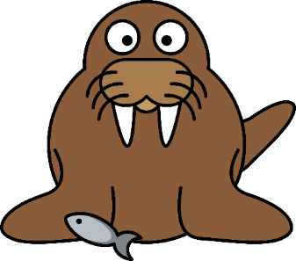
Theme: Winter & Arctic Animals
Time Mon. Tues. Wed. Thurs. Fri.

Daily NO Early NSU *I’ll be
Special Out – reg time Intern leaving at
til Spring Break 10 am-ish
Info. Grade Level for coach
Mtg. @ Nap My Duty Day
Cheer wrestling tourney Skiatook
8:30 – 8:45 Students Dropped Off with Assistants -- upstairs NEB Gym
8:30 – 9:00 Students Dropped Off at Breakfast
8:40 – 9:00 Students Arrive in Classroom / Greet & Welcome
As students come in: smile and greet them; ask if they’ve unpacked their binder and put it on top of their cubby. Then, ask them if they got their name off the door and put it in the bucket on my desk … helps with attendance and learning their names; then have each student go to free play in stations.
9:00 – 9:25 Free Play at Developmental Centers & Learning Stations
and
Letters to Focus on this week: J & D + name writing practice
Sensory Bin – closed
Home & Living / Dramatic Play – household items and baby dolls and stuffed animals for pets
Blocks – red cardboard blocks
Writing Center – scrap / recycled paper, crayons, word banks and flip books, and alphabet chart
Art / Fine Motor Skills: Free drawing on scrap / recycled papers, and coloring sheets + sometimes playdoh + sometimes water color paints at easle
Math / Fine Motor Skills: Manipulatives out for free play and exploration.
Teacher Table – open for help on writing names, catching up on student reading, and assessments. Literacy / Fine Motor Skills: Name Tracing, Letter Practice / Tracing, manipulative letters with pegs plus building their name bags practice.
“BIG” Computer (Hatch – provided by Head Start): early education learning games on Starfall
i-pads – using very familiar technology to most of the students where they can play on PBS Kids, Starfall, tracing letter apps, sign language app, and a math / shape / patterning app, and a Disney Jr., etc.
Library: Winter thematic unit books
Science / Social Studies: closed
Listening: closed
Magnetic Station: open
Poem / Pocket Chart Station: open with thematic unit manipulative pocket charts + gloves and mittens to sort, hang up, and play with.
9:25 – 9:30 Clean Up
9:30 – 9:40 Community Carpet Time Overview:
- Music & Movement – see daily, specific list below
- Calendar Mini Math Lesson – within calendar time & songs & sometimes add in unifix cubes
- Weather (pick a weather reporter from wild sticks on Wed’s)
- Flag Salutes & Patriotic Songs & Moment of Silence
- Name of the Day with kids writing along on wipe boards, Mini Literacy-Themed Lesson / Activity and often times incorporates Mini Math-Themed Lesson / Activity, too.
Community Carpet Time Part 1
MUSIC AND MOVEMENT LIST PER DAY SONGS FOUND ON YOU TUBE:(Alternate list hanging by calendar that are sung to familiar tunes if computer is down.) We usually do 3 songs then move onto calendar and flag salutes.
Mon.
Tue.
Wed.
Thurs.
Fri.

- +++ Penguin Song / Penguin Dance by The Learning Station (following directions / actions)
- Jack Hartman workout / exercise upper case letters & counting songs
- Count to 20 Song
- Learning Letter Sounds A to Z Jack Hartman
- Words Shine When They Rhyme
- Opposites Song
Calendar: Ask what day it is today; what was yesterday? What will tomorrow be? Count to today’s date on the calendar. Sing a days of the week song. They like Adaam’s Family and Happy Days versions best. There’s also a good one by the Learning Station on line called there a 7 days in a week. There’s another song about 12 months in a year by the Learning Station that we also sing periodically.
***Weather on Wednesdays – pull an animal print stick to choose a weather reporter then let them tell the weather help guide them.
***Environmental Word Wall: Mon / Wed / Fri … if kids have brought things into share with the class
Flag Salutes with Patriotic Songs (If feasible sing You’re A Grand Old Flag and / or Oklahoma)
Boy & Girl Line Leaders of the Day flip to the next name in the pink and blue cards up by the calendar.
-------------------------------------------------------------------------------------------------------------------------
9:40 – 9:45 Potty & Wash (for a tiny brain break and for upcoming snack time)
-------------------------------------------------------------------------------------------------------------------------
Community Carpet Time Part 2
9:45 – 10:00 Name of the Day (Round 1: I, like, The / the)
10:00 – 10:15 Snack
10:15 – 10:35 Morning Recess
10:35 – 10:40 Potty, Wash & Drinks
10:40 – 10:45 Read Aloud Pull from the library, read, and Cool Down from Recess
Mon. Tue. Wed. Thurs. Fri.
Tues – Hush Little Polar Bear Read by Cynthia 1 ½ mins.
Thur – The Whale Who Ate Everything by Dan Devoe 4 mins. +
Fri – The Polar Bear and the Snow Cloud by Jane Cabrera almost 5 mins.
10:45 – 10:55 Explanation of Work Stations (modeling & detailed instructions)
10:55 - 11:30 Work Stations / Center Rotations

Monday
Julie 2 – Read a Weekly Reader Fuzzy Penguin Chick
Circle Table 4 –
Square Table 4 – match and paste the correct label of the arctic animals then practice writing their labeled parts.
Teacher Table 4 – go over guided reading packet with kids and rules with books sent home in folder
BIG Computer 2 - learning technology games
ipads 2 - learning technology games
Library 2 – winter themed books
11:50 – 11:55 Bathroom Break: Potty, Wash, and Get a Drink
11:55 – 12:00 Walk to Lunch
12:00 – 12:35 Lunch
12:40 – 1:10 Recess
Tuesday
Julie 2 – Read a Weekly Reader Fuzzy Penguin Chick
Circle Table 4 –
Square Table 4 – write the room polar bear style – upper case letters
Teacher Table 4 – guided reading (upper case letters + I, like, The / the)
BIG Computer 2 - learning technology games
ipads 2 - learning technology games
Library 2 – winter themed books
11:50 – 11:55 Bathroom Break: Potty, Wash, and Get a Drink
11:55 – 12:00 Walk to Lunch
12:00 – 12:35 Lunch
12:40 – 1:10 Recess
Wednesday (NOT early out day; normal time ‘til Spring Break)
Julie 4 – white handprint on mitten or snowman dobber & pasting art
Circle Table 4 – color the penguin (ONLY USE CRAYONS AND SAVE FOR SCIENCE EXPERIMENT LATER THIS WEEK ON WAXY FEATHERS ON PENGUINS REPEL WATER AND HELP KEEP THEM WARM!) and play the Bang game practice naming letters and sounds
Square Table 4 – write the room polar bear style lower case letters
Teacher Table 4 – guided reading (lower case letters + I like The / the)
BIG Computer 2 - learning technology games
ipads 2 - learning technology games
Library 2 – winter themed books
11:30 – 11:35 Bathroom Break: Potty, Wash, and Get a Drink
11:40 – 12:10 Lunch
12:10 – 12:40 Recess
Thursday
Julie 2 - white handprint on mitten or snowman dobber & pasting art
Circle Table 4 -
Square Table 4 – trace the penguin #s 1-20
Teacher Table 4 – guided reading (I, like, The / the and #s flashcards, counting, and writing numbers.)
ipads 2 - learning technology games
Writing Center 2 – January Journaling using picture and word prompts
11:50 – 11:55 Bathroom Break: Potty, Wash, and Get a Drink
11:55 – 12:00 Walk to Lunch
12:00 – 12:35 Lunch
12:40 – 1:10 Recess
Friday
Julie 2 = white handprint on mitten or snowman dobber and pasting art
Circle Table 4 – Wintry Arctic Alphabet
Square Table 4 – color shapes on the penguin the correct colors
BIG Puzzle on BIG Carpet or Blocks or Home & Living 4 –
BIG Computer 2 - learning technology games
ipads 2 - learning technology games
Library 2 – winter themed books
11:50 – 11:55 Bathroom Break: Potty, Wash, and Get a Drink
11:55 – 12:00 Walk to Lunch
12:00 – 12:35 Lunch
12:40 – 1:10 Recess

+++ Feed the Penguins the Correct number of goldfish
+++ Put the Penguin cups in the correct number order and practice counting

1:15 – 1:20 Pack Binders
1:20 – 1:35 Arctic Animal Study & Science
Tues -- How Do Whales, Penguins & Polar Bears Keep Warm? Sci Show Kids 5 mins.+++ The Blubber Experiment
Thurs -- Animals with Winter Coats! Sci Show Kids 5 mins. + Demonstrate how the blue colored water repels off of the waxy crayon colored penguinjust as it would waxy feathers in the frozen, arctic winter.
Fri – Compare and Contrast Circles – Penguins & Birds
- Penguins – swim, webbed feet, waxy feathers, eats fish, land & water, daddy’s stand over babies in eggs and protect them
- Birds – fly, wings, feathers, eats worms, air & land, babies in nest and mama protects and brings food to them.
- Both – Beaks, wings, feathers, walk
Or …
Sleepy Bear Weekly Reader
Martin Luther King Jr. Day Weekly Reader
1:35 – 1:40 Get a Drink, Potty & Wash
1:40 – 2:55 Rest / Naptime
2:50 – 2:55 if needed: Potty / Wash / Get a Drink
2:55 – 3:00 Read Aloud a Book, Sing Some Songs, or Play an Interactive Learning Game with Students

Review Letters Songs: G, S, J & D

*** Let the kids practice walking / waddling like a penguin with a football between their knees and keeping it there going down and around a cone.
*** Let the kids practice protecting an egg between their feet with a pillow body / belt and football between their legs and go around a cone.

3:00 Bus Rider Dismissal
3:05 Daycare / Aftercare Dismissal
3:10 Walk up Students to Parent Pick Up & Dismissal
3:30 All Students should be picked up
Lesson Plans are subject to change based on difficulty and schedule changes throughout the week.

